**Lab 01**

What you need to know to answer questions 10 and 11

You do not need to submit this document. This is a guideline for Questions 10 and 11 in Lab 01.

**Question 10:**

Too see the table’s constraint, you can click on the table name “dbs211_customers”. Then, choose “Constraint Tab”. You see the list of constrains, their names, their type, and more. We will learn about table constraints soon.

For instance, if you want to see what column is the primary key in the dbs211_customers table, double click on “primary key” and you will see the column name and column number for the primary key. The primary key is the unique identifier in a table. See the image below for dbs211_customers constraints.

Do the same thing to see constraints in other tables.

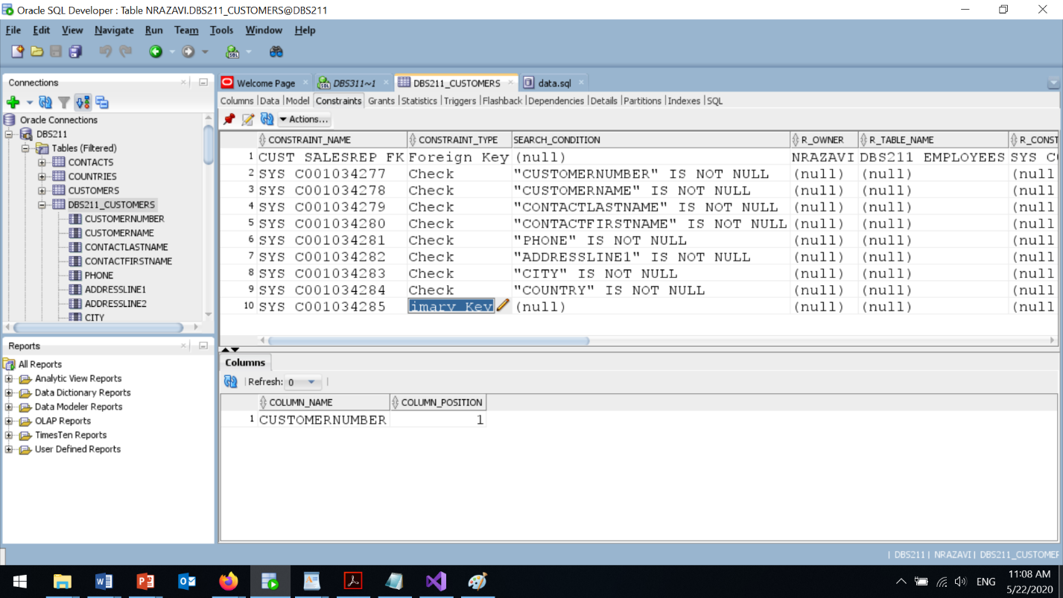

**Question 11:**

When you open a new worksheet (SQL editor), by default it does not have the line number. To have the line number in you SQL editor, you can go to

**Tools > Preferences > Code Editor > Line Gutter**

and check "Show Line Numbers".

When you get back to your SQL editor, you see the line number appears there.

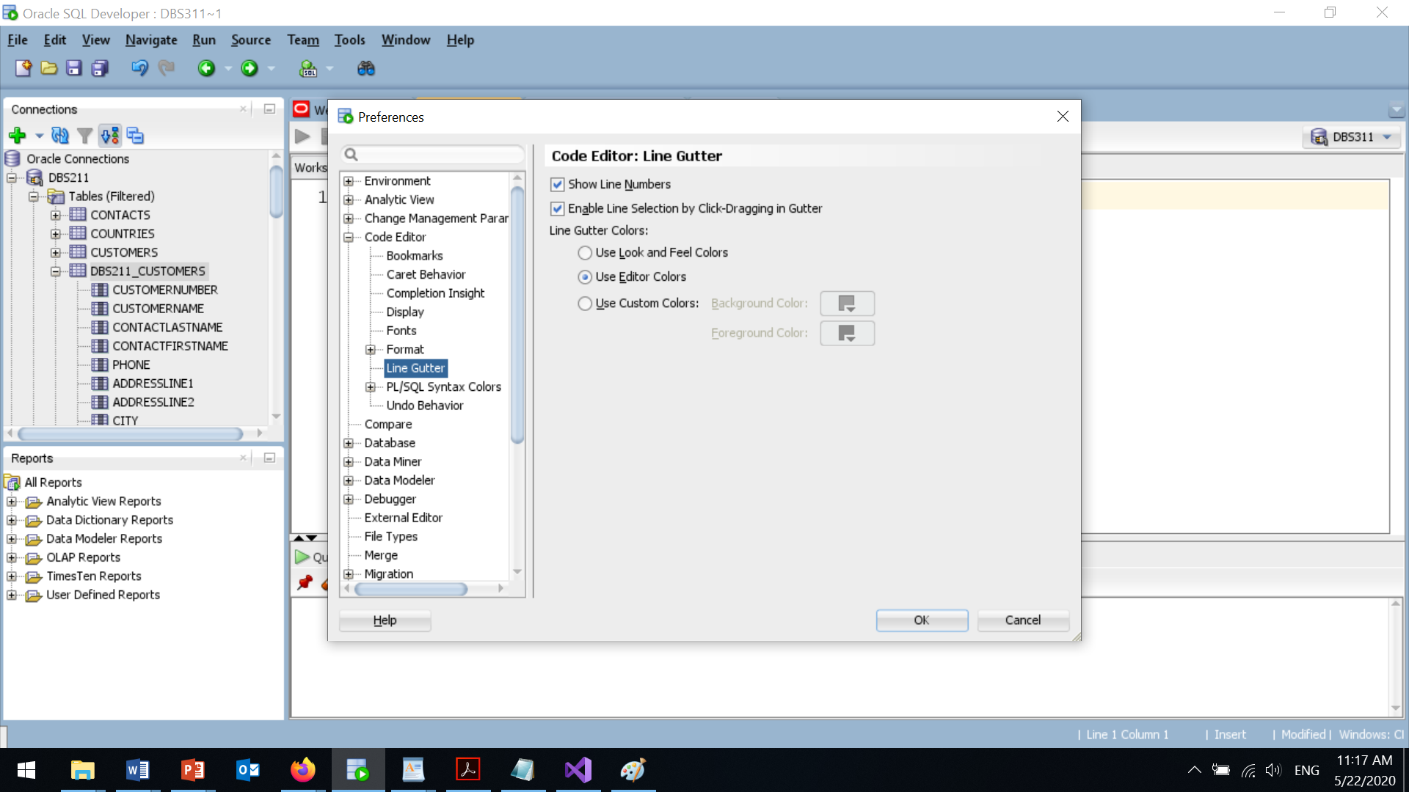

In the same navigation panel, you can go to "Fonts" and change the font size.

There are other options that you may want to try to customize your SQL editor.